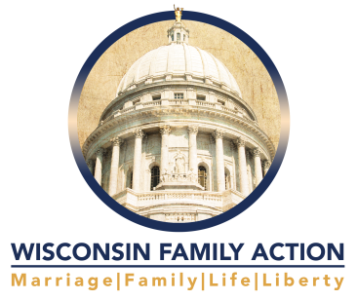
PO
PO Box 7486 • Madison WI 53707
608-268-5074 (Madison) • 866-849-2536 (toll-free) • 608-256-3370 (fax)
Email: info@wifamilyaction.org • Web site: www.wifamilyaction.org

Testimony in Support of Assembly Bill 128
Assembly Committee on Health
Public Hearing, April 19, 2017
Julaine Appling
President, Wisconsin Family Action

Thank you, Chairman Sanfelippo and committee members, for the opportunity to testify in support of Assembly Bill 128.

Wisconsin Family Action (WFA) believes this bill is necessary to bring the state fully in compliance with existing state prohibitions on funding abortion, as cited in Section 20.927 of our state statutues.

Providing a benefit in the form of a health insurance policy to state employees, state annuitants or local government employees whose local government unit participates in a Group Insurance Board health insurance plan certainly constitutes state funding. Since the law clearly prohibits state funds from subsidizing abortion, with the exceptions as noted in 20.927, making health insurance policies that include abortion available to state employees and the others as noted obviously is funding abortion and should therefore not be permitted.

It is time to bring this outlier into conformity to state law.

Wisconsin Family Action urges the committee to support this bill and move it to the full Assembly for a vote.

Again, thank you for this opportunity; and I am happy to answer questions.

